Here we are: Krista Bradford, Helen Billinge and Natasha Newport, the lucky teachers from the Kent and Medway Maths Hub, selected to take part in the 2019 Shanghai exchange. We knew we were going to develop our understanding of Teaching for Mastery; in reality, we learnt so much more.
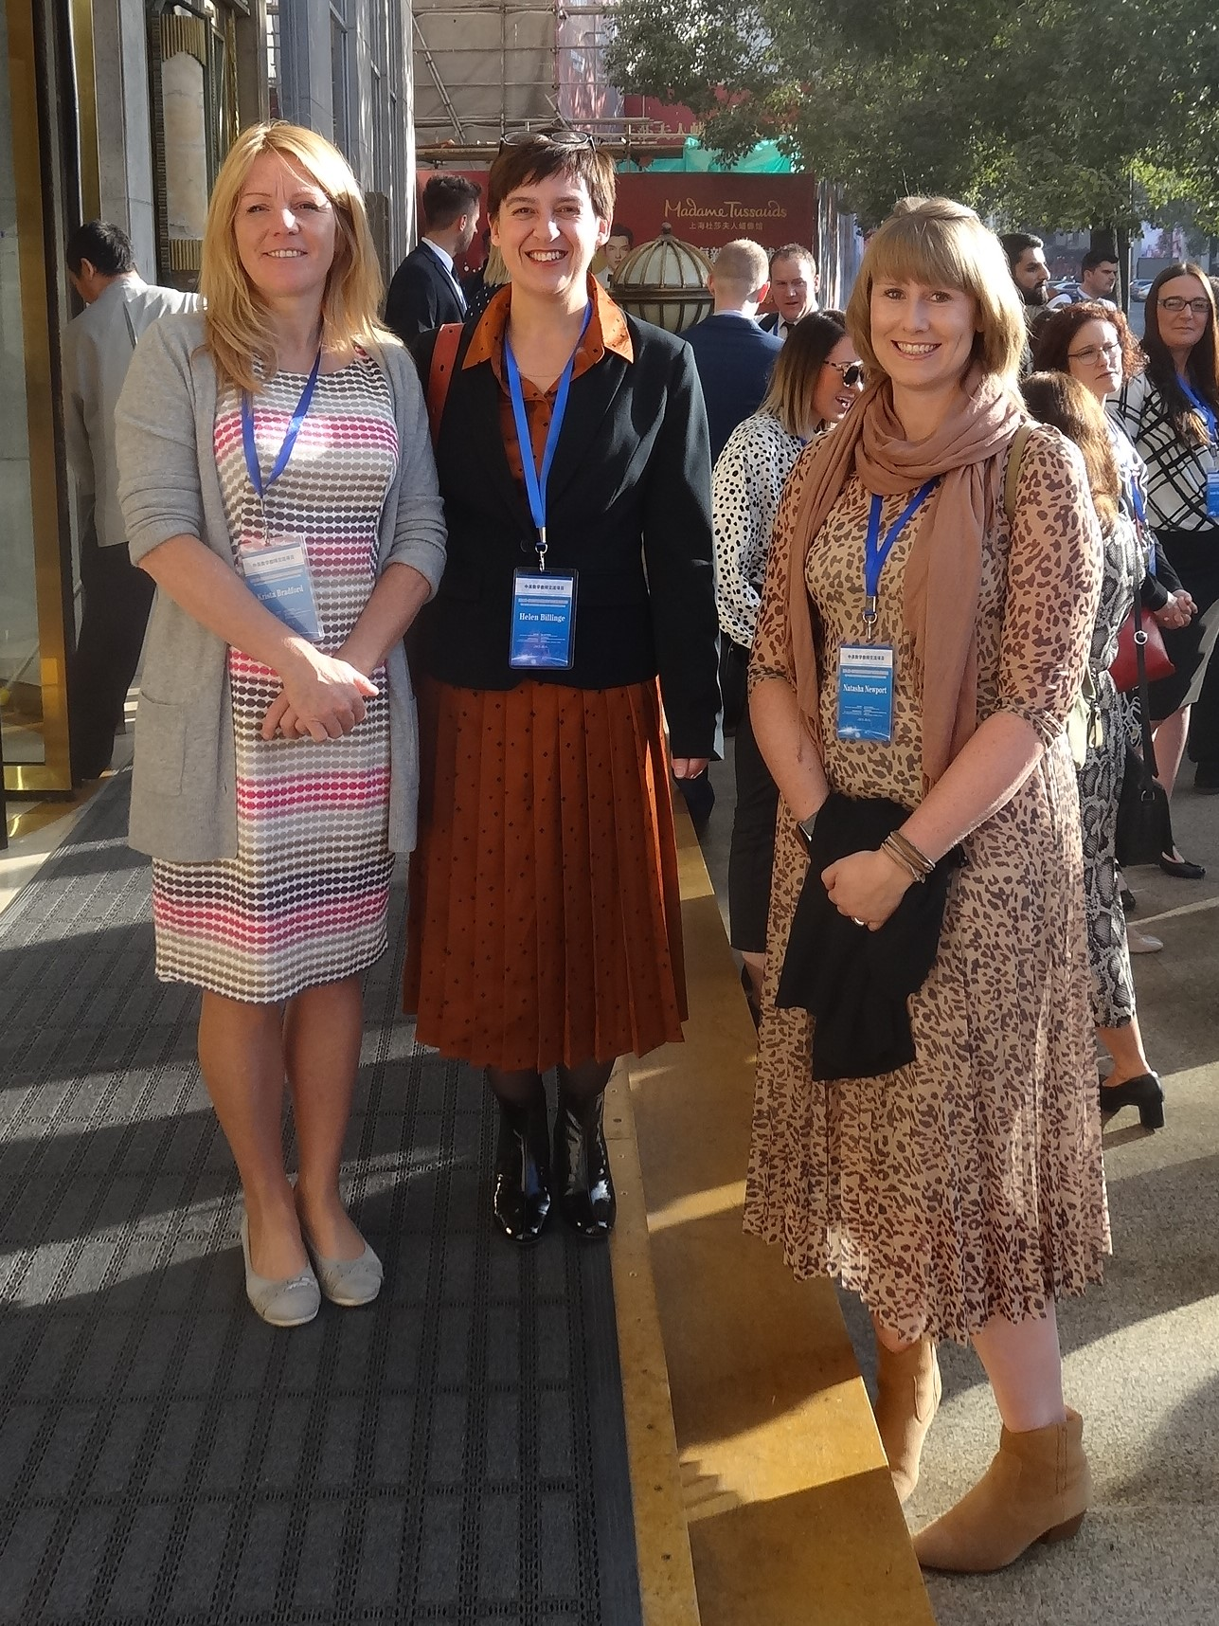
Over the 2 weeks we each observed between 15 and 20 lessons, taught a lesson, took part in formal and informal TRGs at our schools and talked at length with our UK counterparts in the evenings. The personal impact has been on many levels and, as we return to our schools (jetlagged but enthused), we look forward to developing our own teaching.
Give an example of how your maths subject knowledge developed?
K:. There was a Grade 4 lesson that made me think again about inverse relationships. The teacher used ‘tree diagrams’ to discuss how to calculate a missing number in calculations involving all the operations. The children, who fluently identified the missing numbers, were then taken through a series of steps to identify the calculations they used. Did they use the same operation (eg 14 – ? = 9 uses 14 - 9) or the opposite (eg ? – 5 = 9 which uses 5 + 9). The teacher was constantly drawing attention the relationships between the numbers. The ‘special inverse’ was identified and, using all operations and all positions of missing numbers, the children explained why it was only sometimes needed. After generalising and categorising, they used this knowledge to solve complex multistep puzzles. I had to puzzle over the categorising and generalising and realised how beneficial it was for the children’s understanding of the operations.
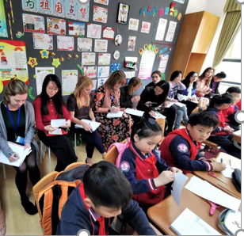

H: In both of the middle schools that we visited, Grade 7 students were learning about algebraic fractions. We saw two lessons each on introducing algebraic fractions and basic properties of algebraic fractions. All four of these lessons made me realise that I have not been precise enough in teaching either fractions or algebraic fractions. In the introduction lessons, the teachers highlighted the difference between an integral expression (e.g., $\frac{m^{2}-n}{3}$ since this can be written as $\frac{1}{3}m^{2}-\frac{1}{3}n$) and an algebraic expression with variables in the denominator (e.g, $\frac{m^{2}-n}{m+n}$). Algebraic fractions are expressions of the form $\frac{A}{B}$ where A can be any expression, but B must be an expression containing variables, and crucially that B ≠ 0. This is something that I have only really emphasised when teaching domains of functions in KS4 and KS5, but it was clear that the fact that 0 cannot be the denominator any fraction had been emphasised since students were first introduced to fractions.
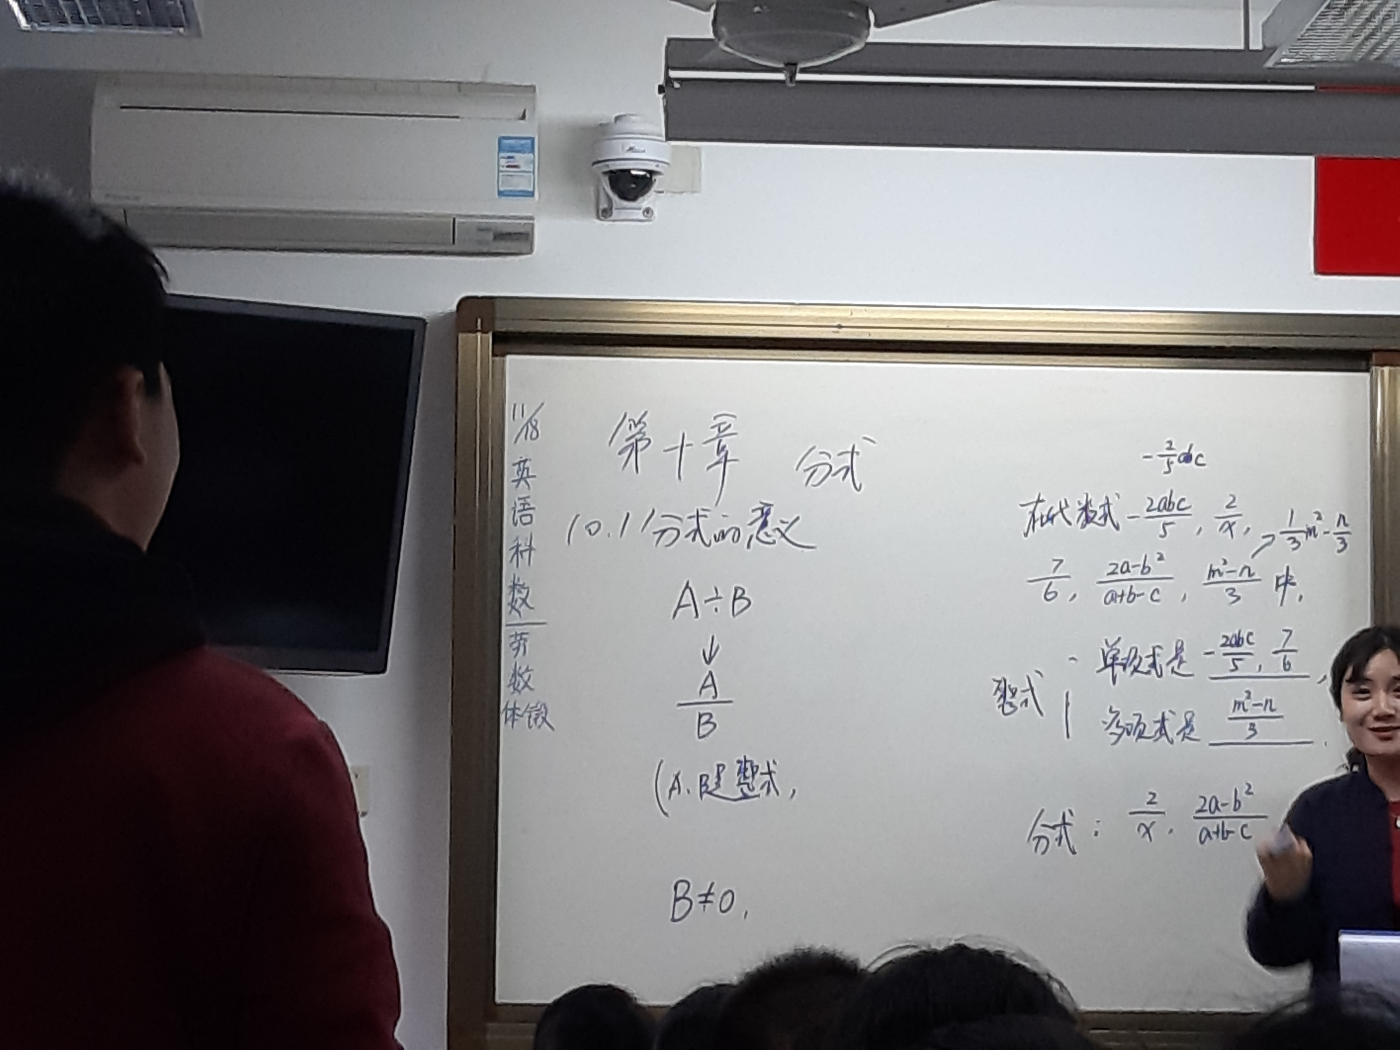
N: One of the lessons which made me think most, was a Grade 4 lesson using the associative law. I knew what associative law was but hadn’t really thought explicitly about how to teach it, or about asking children to prove which mathematical operations it was linked to. During the lesson, children were able to clearly demonstrate their fluency of understanding and justify their responses with calculations. The teacher gave the example (463 + 455) + 545 = 463 + (455 + 545) and children gave supporting number sentences, such as (5 + 2) + 8 = 5 + (2 + 8) and (2 + 3) + 7 = 2 + (3 + 7). The children chose lower numbers, which they could calculate easily to enable them to prove or disprove a statement.

What did you learn from planning and teaching a lesson in Shanghai?
K: We chose to base our lesson on one that we had observed. We hoped that it would be quite straightforward but, during the planning process, we realised just how complex, precise and demanding it actually was. I became fully aware of how expert our Shanghai teacher was; during the planning process, she constantly asked us to adjust our questions to be more precise or to change the order of our questions. She also made me appreciate the emphasis that is placed on asking the children to summarise and check the learning at each step. She was constantly concerned that we would make assumptions in the lesson rather than confirming the understanding before moving on. We were teaching a grade 2 class and the teaching process itself was slightly scary and a little tricky with the translation that was needed! In true Shanghai style it was all filmed and we were presented with a CD to treasure by lunchtime.
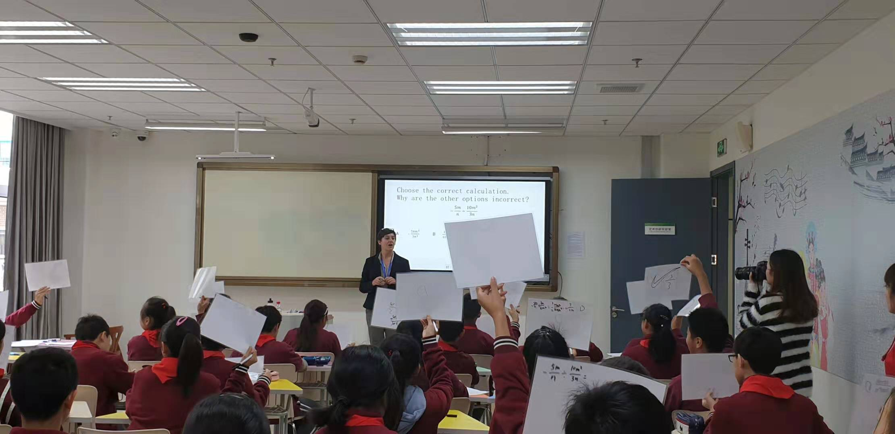
H: We were asked to teach the third lesson on algebraic fractions. We had seen the first two lessons and so had a very clear idea of what the students would be expected to know, what to emphasise and what common misconceptions needed to be drawn out. We were very lucky to be a part of a weekly planning meeting, so we presented our powerpoint to a group of teachers at the school before we delivered it. They were happy with the examples and questions we used, but asked us to make sure we explicitly drew out the key learning points as we went along. The actual lesson was much less intimidating as a result, but it went more slowly than we had planned mainly due to the students translating their rather technical answers into English from a cheat sheet.
N: I thought I understood the importance of repeating the stem sentence or generalisation, however, when it came to observing and then teaching our lesson, it became much more evident to me how strong the focus was on this part of the lesson. We were encouraged to record anything valuable and key to the lesson on the blackboard as well as on our Powerpoint. The key learning point was repeated several times by the children - both individually and as a group. When it then came to the end of the lesson and children were asked what they had learnt, many were able to repeat this generalisation. It became obvious how important this was and luckily, even at the end of our lesson, the children were able to use this to tell us what they had learnt!
What immediate impact will the Shanghai experience have on your own teaching?
K: At the end of each lesson ‘the secret of the maths’/the key concept was identified and articulated by the children. This was their ‘take away’ skill to practise and apply later. I realised that making this generalisation so explicit is what made the learning so strong. I am going to aim for my children to articulate the key concept in their own words and to ensure they are consciously applying this when completing their independent tasks. To master a skill the children need to be able to articulate it. For it to be theirs to keep, it needs to be tangible. I was also impressed with the short intense focus of the Shanghai lessons supported by the regular breaks and so I intend to create a movement break between the whole class session and the independent practice.
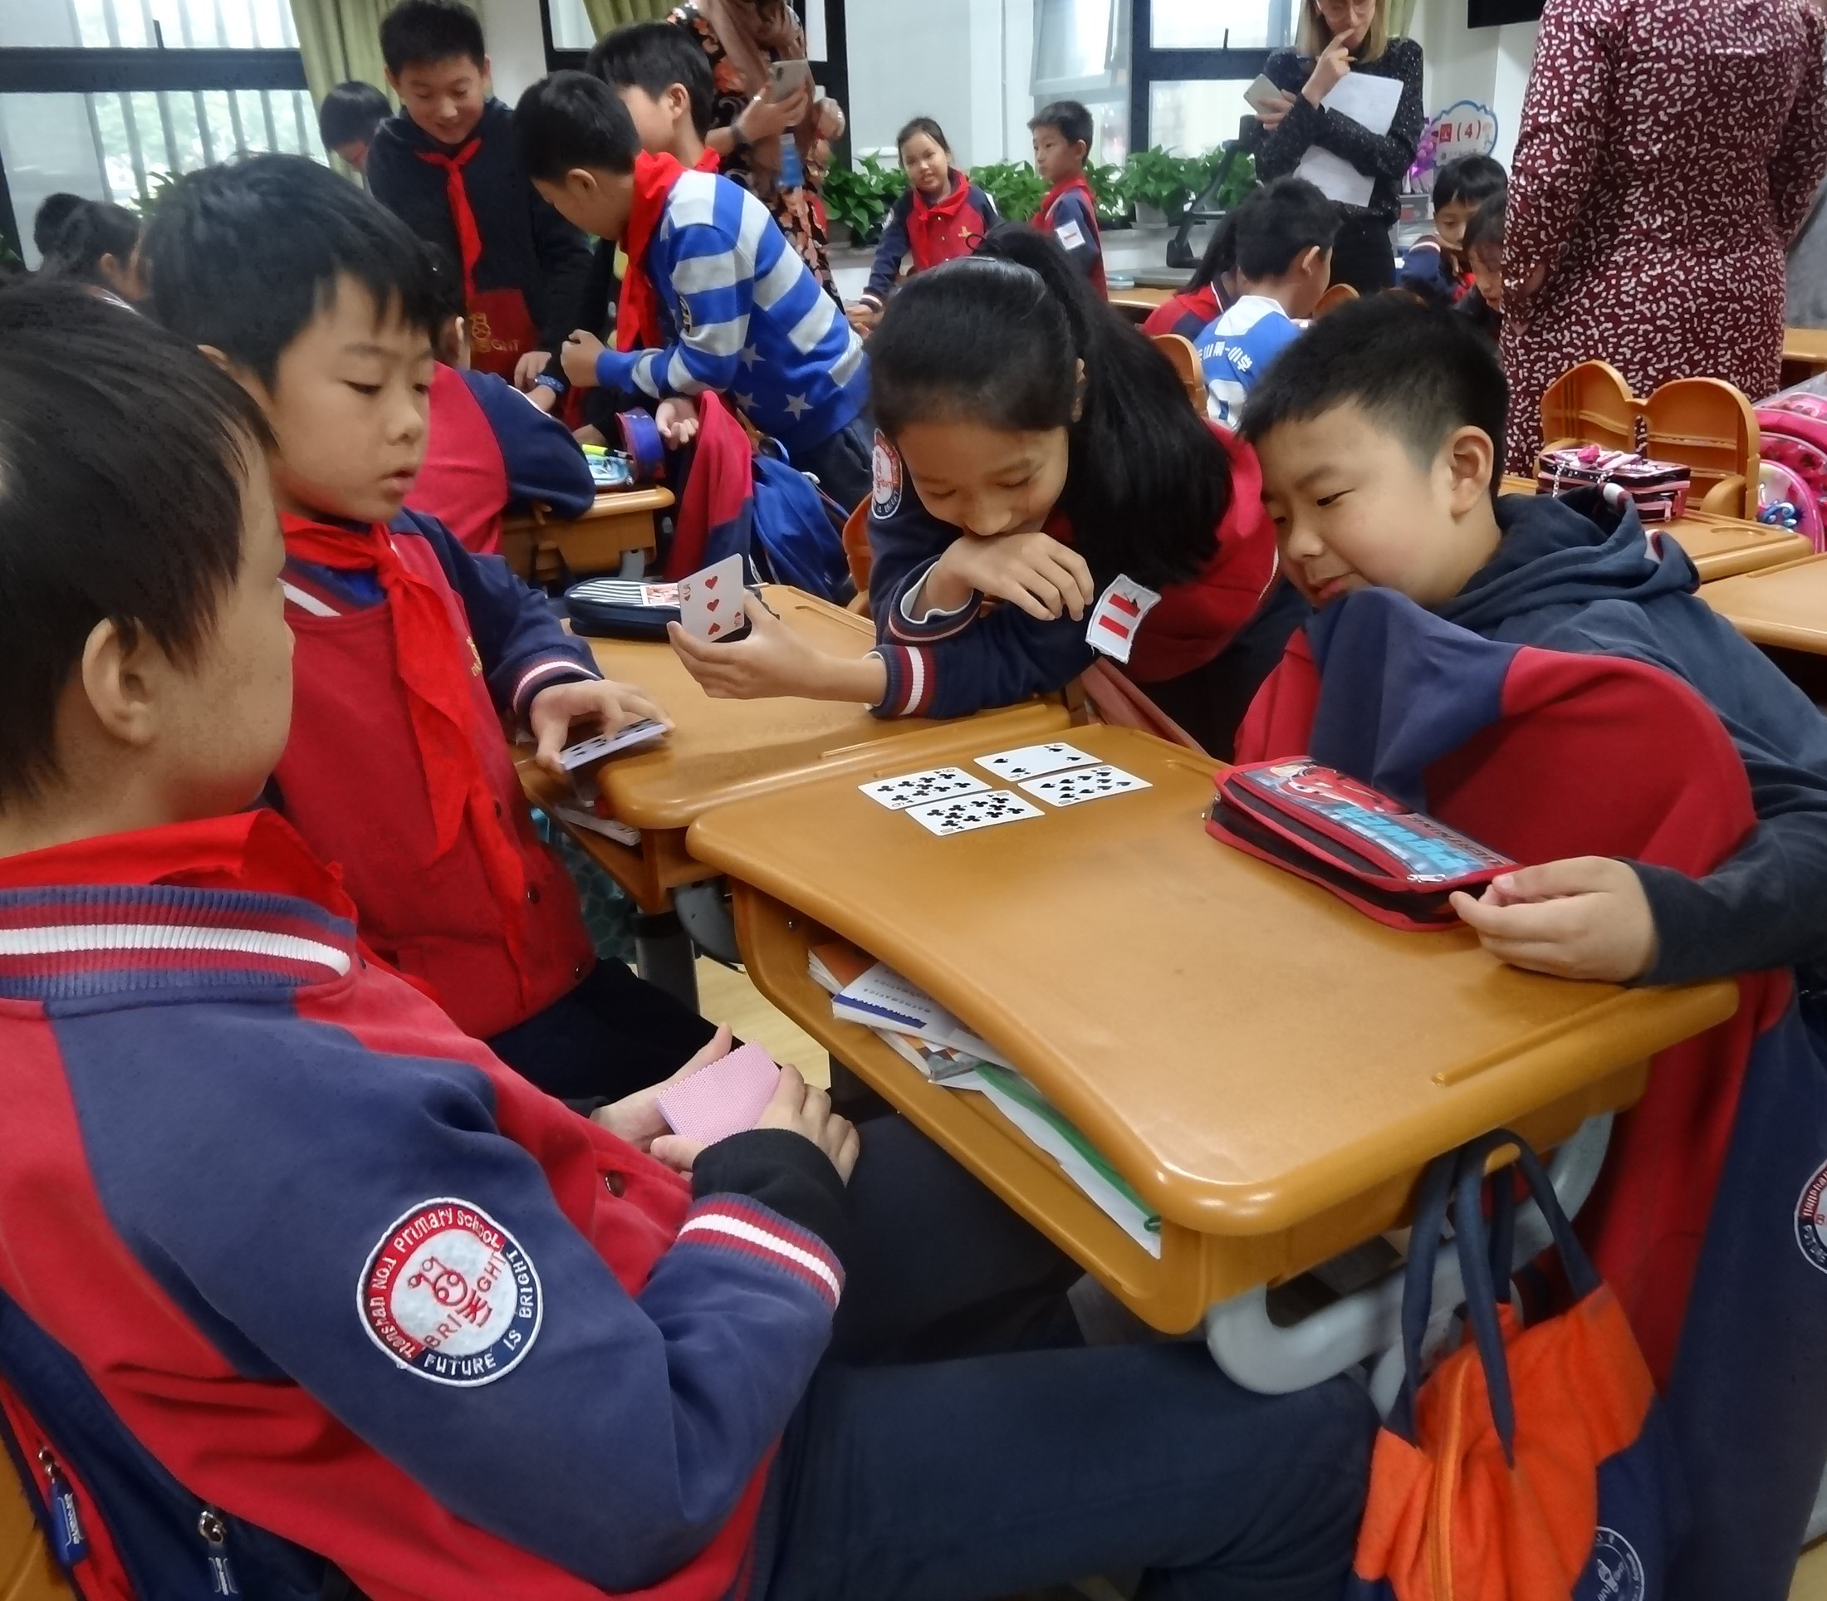
H: Two things struck me that I could implement straight away. One was being much more precise about the language and notation used to describe mathematical objects and processes. For example, using the terms dividend and divisor when taking about division calculations makes it much easier for students to explain their reasoning. This meant that there was no confusion about what anyone, student or teacher, was talking about. It also made it much easier for students to explain their reasoning with absolute clarity. The second was to generalise the key learning points constantly. At every opportunity, learning points were made explicit with a written statement, and where relevant, an algebraic generalisation.
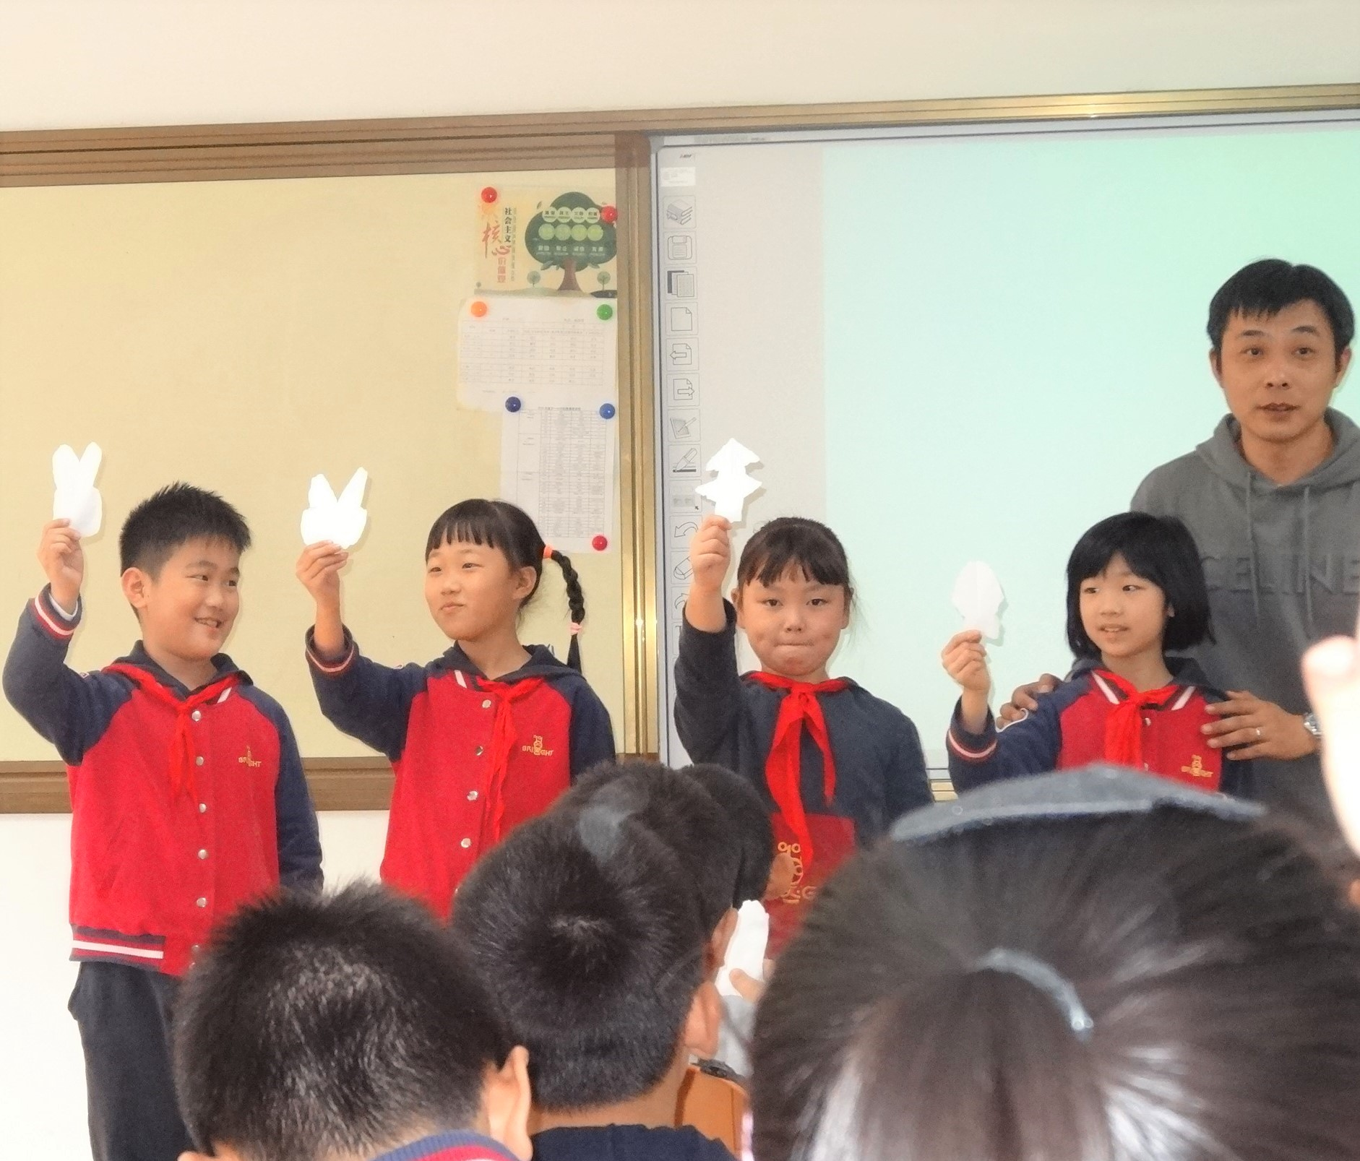
N: I will strip back my lessons and not focus on using manipulatives, representations, variation and other mastery tools unless they support the key point of the lesson. In every lesson we observed, the key point was just that – key! That was the teacher’s starting point and everything else linked to it. Representations were carefully chosen to reveal the key point, as were questions. Manipulatives were only used in the lesson if they supported the key point. I will need to look carefully at planning with my team and ensure our focus remains on that key point and everything else supports the understanding of the key point. I would like every child in my class to be able to acknowledge the key point in the lesson in their reflection at the end, focussing on what they have learnt.

