St Peter-in-Thanet CE Junior School

How to support your child’s learning:
A parents’ guide
Year 6 Terms 1 & 2

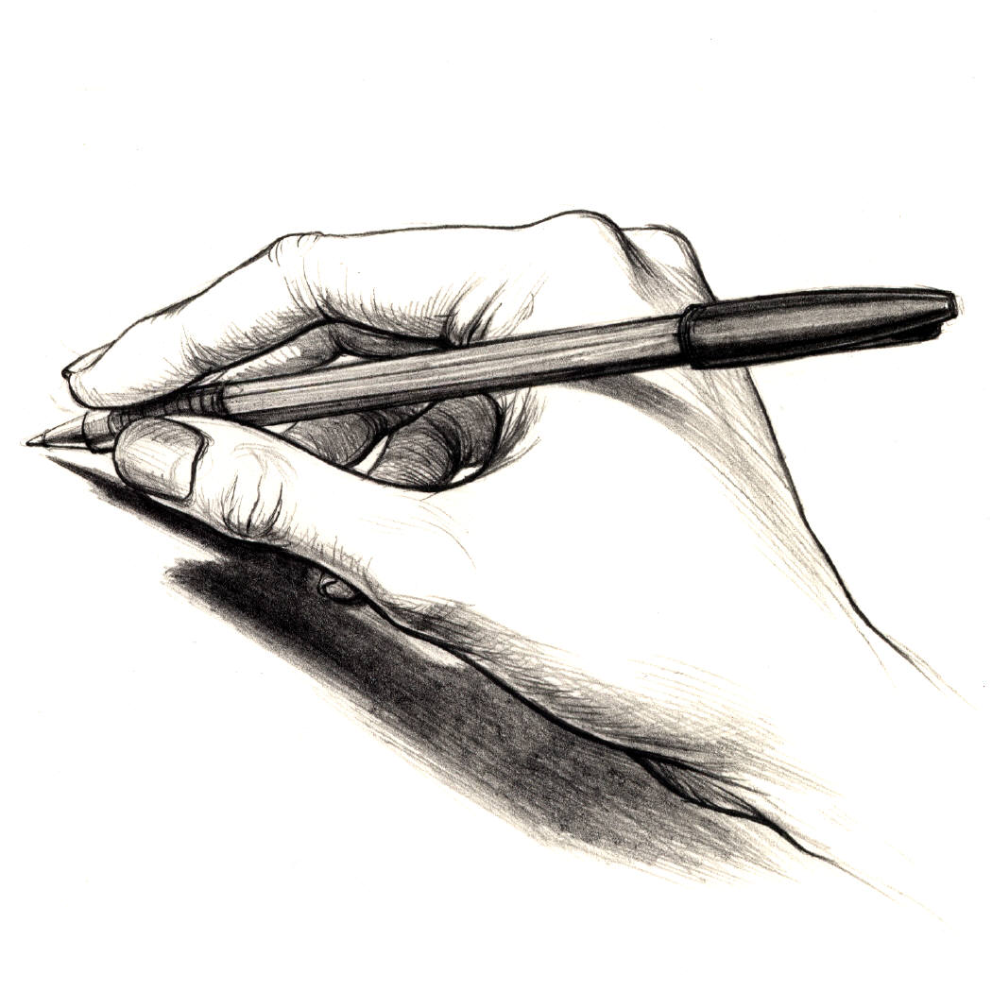
Literacy
We will be…
introducing
children to narrative poetry.
Children will talk about the
work of a good range of authors including use of effective vocabulary, atmosphere, etc.
We will be looking at the poet’s choice of vocabulary and how atmosphere and images are created. Children will write stories based on these poems.
Other genres studied will include Shakespeare, autobiography/biography, argument and journalistic writing.

Children will be working with buddies on shared reading

Literacy homework is set on a Wednesday and due back by Friday

Maths:

We will be …
- Consolidating work on
place value
- Looking at strategies for problem solving and familiarising pupils with a range of techniques for responding to questions including use of calculators
- Using efficient written methods
- Finding simple percentages and fractions of whole numbers
- Making and drawing shapes with increasing accuracy
- Using units of measurement and converting between units
- Reading and interpreting scales
Children need to know tables facts up to
10 x 10

Maths homework is set on a Monday and due back by Wednesday

Science:
We will be looking at …
the shapes and relative sizes of the Earth, Sun and Moon. Using models they learn how the three bodies move relative to each other and how these movements relate to night and day.
Experimental and investigative work in this unit focuses on:
• making observations and recognising patterns in first hand and secondary data
• representing data in graphs.
Work in this unit offers opportunities for children to relate scientific knowledge and understanding to familiar phenomena e.g. day length, year length and to consider scientific evidence about the Earth, Sun and Moon.

Web links:
www.bbc.co.uk/schools/revisewise
www.bbc.co.uk/schools/bitesize
www.woodlands-junior.kent.sch.uk/homework

Music
Children will be learning to play the guitar and will be developing their understanding of music theory.
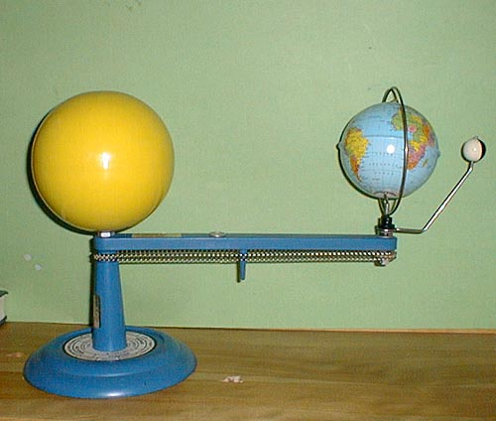

Art
Children will be doing still life drawings

PE
Rugby – Children will be learning skills and tactics
needed to play touch rugby, including passing,
tackling, and running with the ball

Other themes:
History/Geography
Investigating the local area and uses of land. Understanding a variety of map scales and symbols
Information Communication Technology – Spreadsheets. Inputting simple formulae. Creating graphs. Using a spreadsheet to calculate a running balance
Religious Education –Judaism - studying the Torah and what it means to Jews. Visiting a local synagogue.
Design & Technology – Shelters: Designing and making a product, looking at joining techniques.
French – Expressing likes and dislikes; clothes
Personal, Social & Health Education – Drug awareness: to be aware of the difference between medicine and drugs

